Machine Learning is usually divided into types based on how the model learns, and “classification” is one specific technique within those types.

Types of Machine Learning
1. Supervised Learning
2.Unsupervised Machine Learning
3.)Semi Supervised Machine Learning
4.)Reinforcement Learning

Two main tasks in Supervised Machine Learning:-
- Classification → Output is a category
Example: spam / not spam
- Regression → Output is a number
Example: house price prediction

Types of Classification

1. Binary Classification
- Only 2 classes
- Example:
  - Spam / Not Spam
  - Fraud / Not Fraud
2. Multi-class Classification
- More than 2 classes
- Example:
  - Cat / Dog / Horse
3. Multi-label Classification
- One input can have multiple labels
- Example:
  - Movie → Action + Comedy
Common Classification Algorithms
- Logistic Regression
- Decision Trees
- Random Forest
- Support Vector Machine (SVM)
- K-Nearest Neighbors (KNN)
- Neural Networks
Gradient Descent is a method used in Machine Learning to find the minimum value of a function (usually the loss/error).
It reduces error step by step by moving in the direction where the error decreases the most.
y=mx+c
y=m1xi+m2x2+m3x3
Types of Regression:-
1.)Linear Regression:-
- Fits a straight line
- Used when relationship is simple
2.)2. Multiple Linear Regression
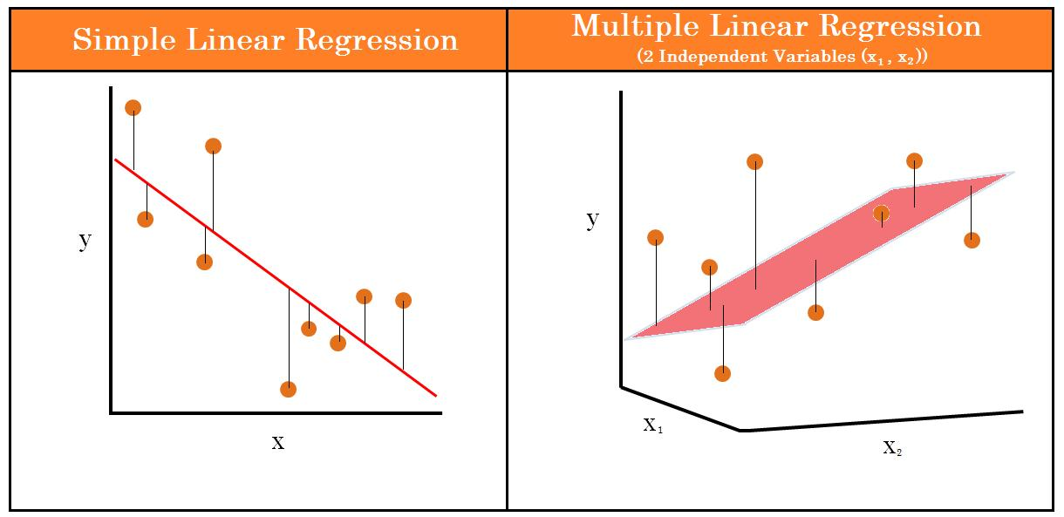
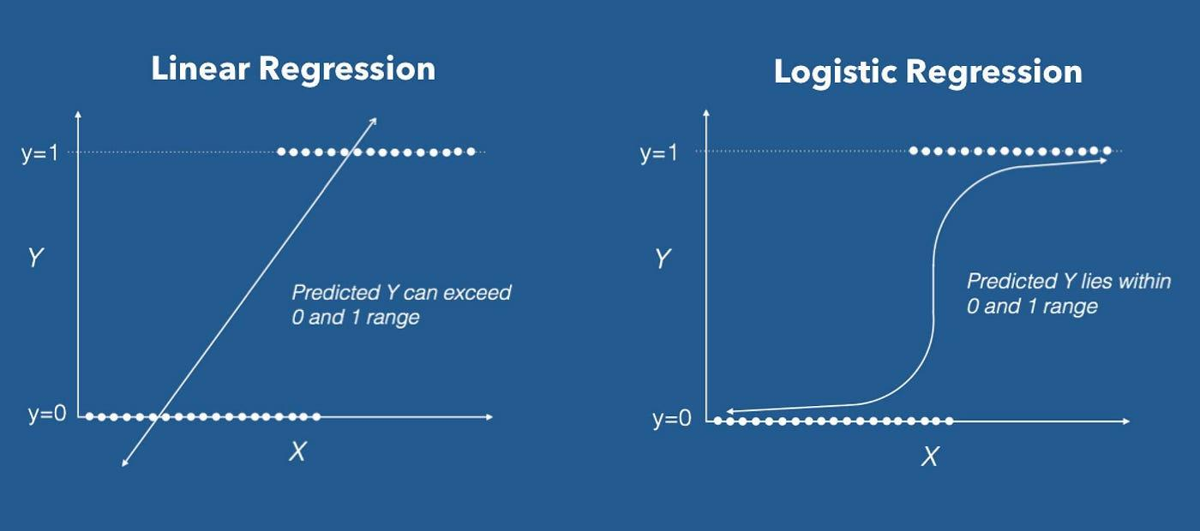
Linear Regression predicts continuous values by fitting a best-fit straight line between input and output variables.
- Uses multiple inputs
- Still predicts a number
👉 Example:
House price = size + location + bedrooms
3. Polynomial Regression
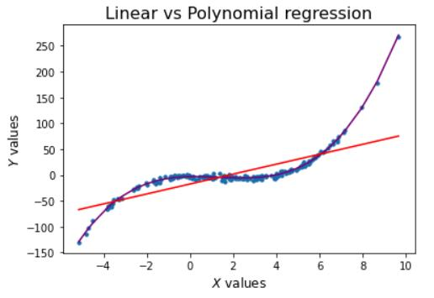
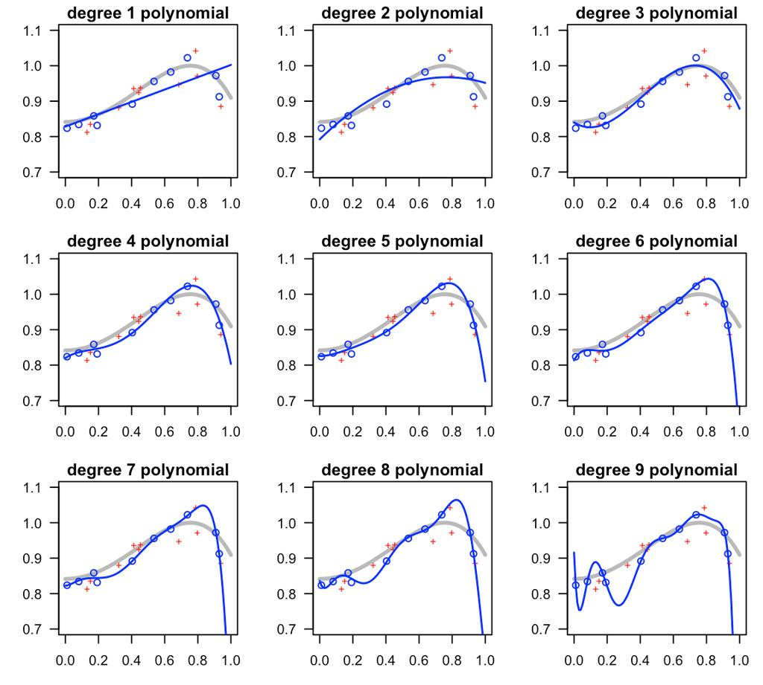
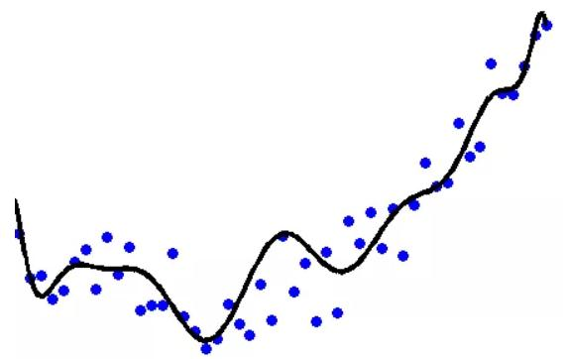
6
- Fits a curved line
- Used when data is not straight
👉 Example:
Growth over time (curved trend)

4. Logistic Regression
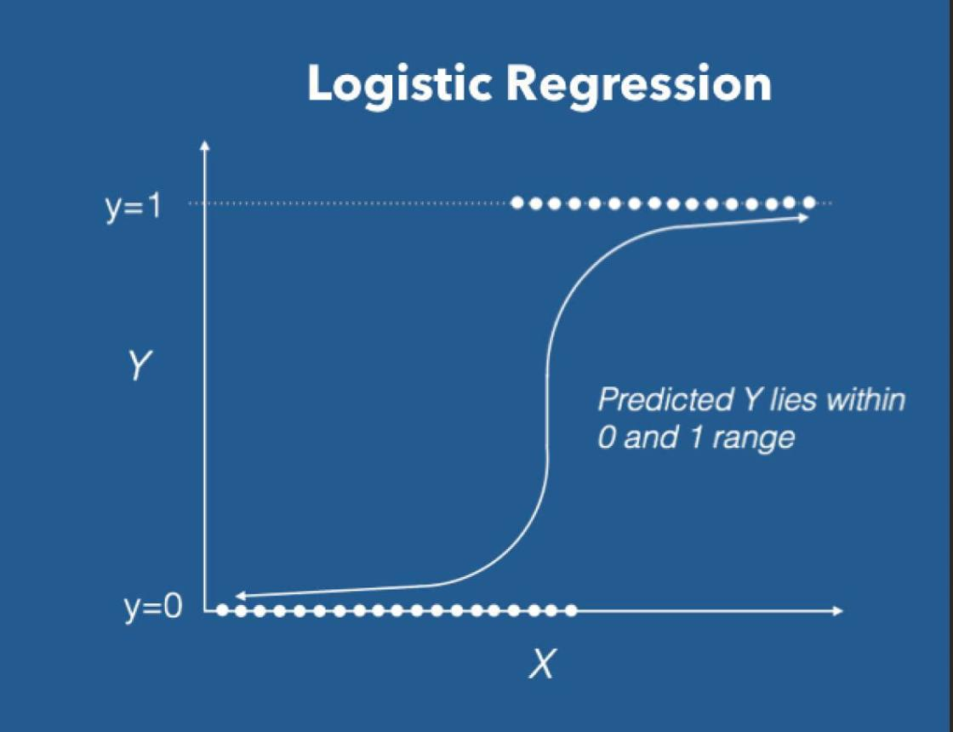
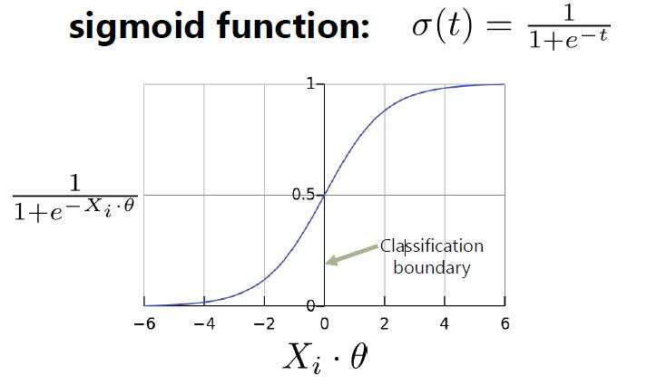
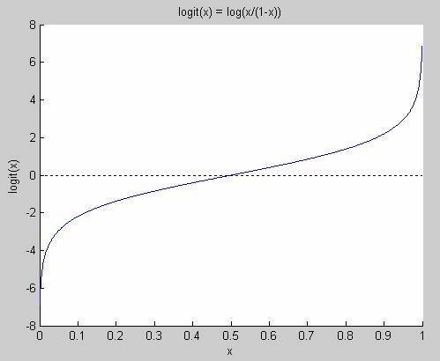
6
- Used for classification (yes/no)
- Output is probability (0 to 1)
👉 Example:
Spam or Not Spam

5. Ridge Regression
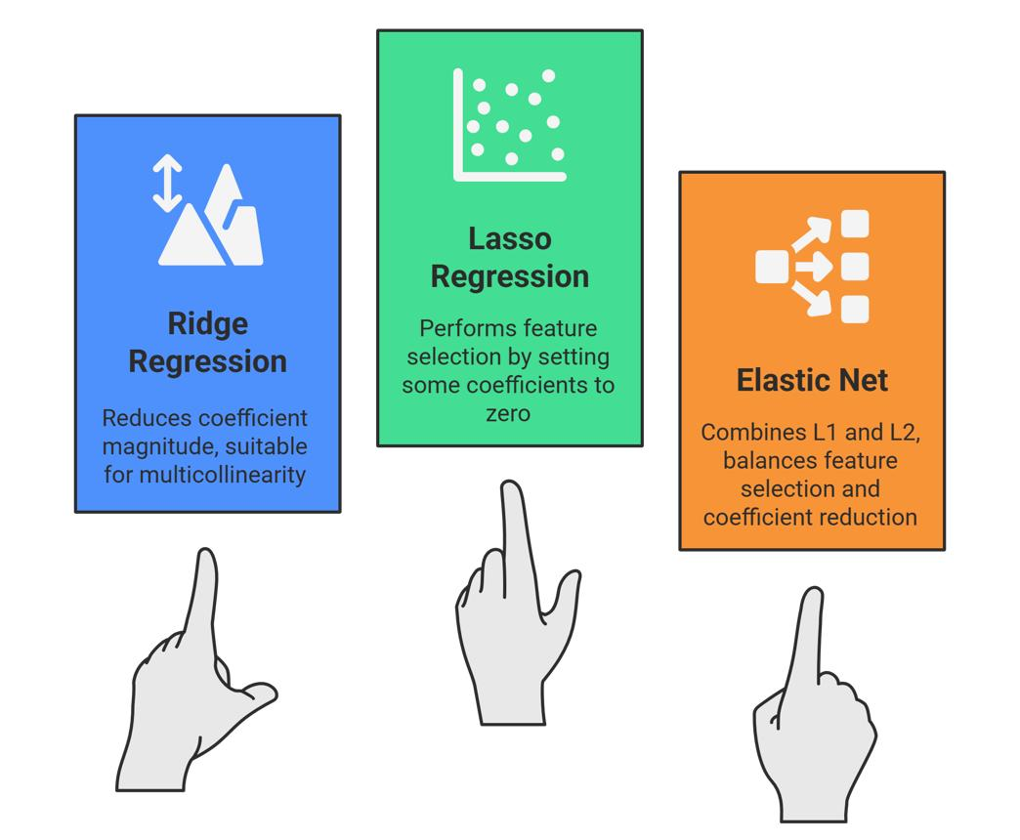
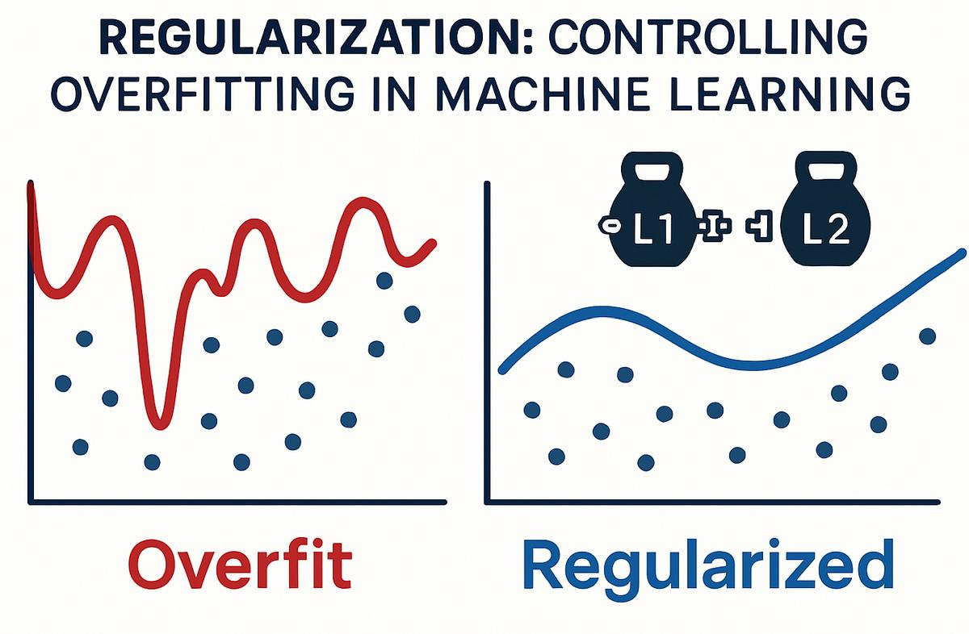
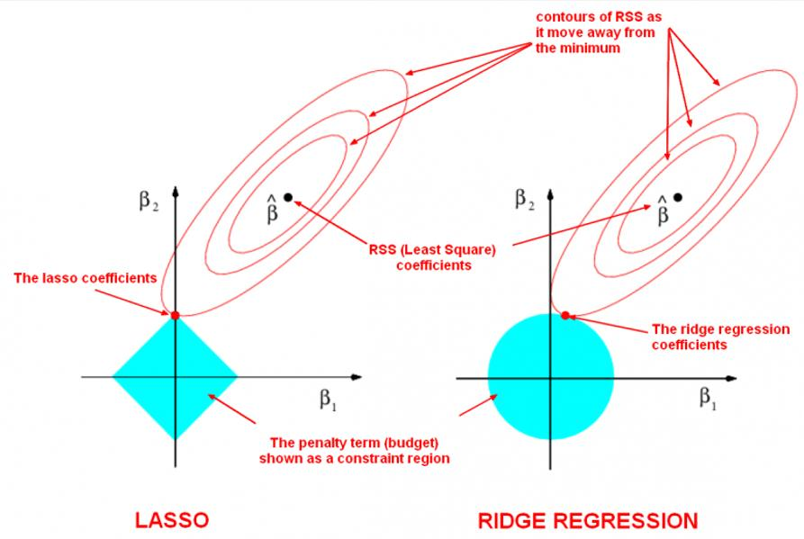
6
- Prevents overfitting
- Shrinks coefficients

6. Lasso Regression
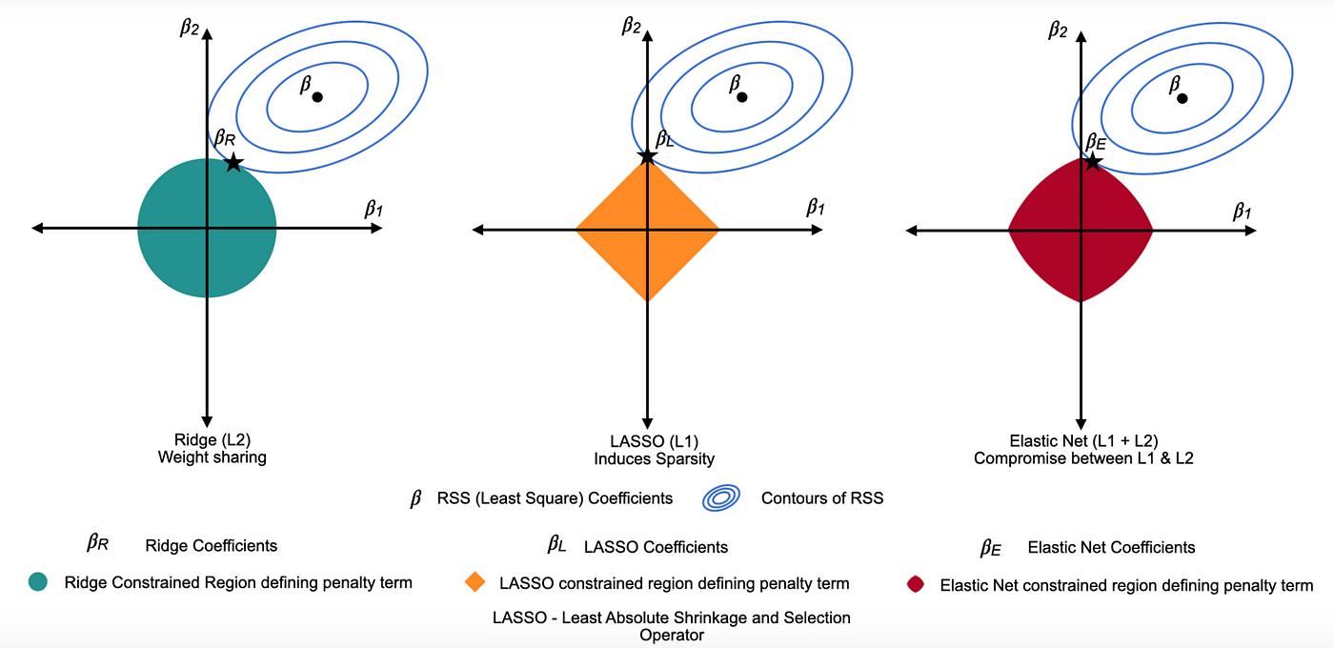
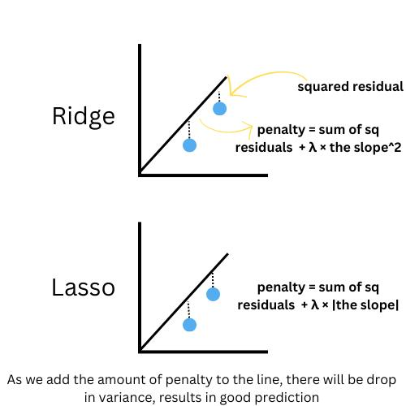
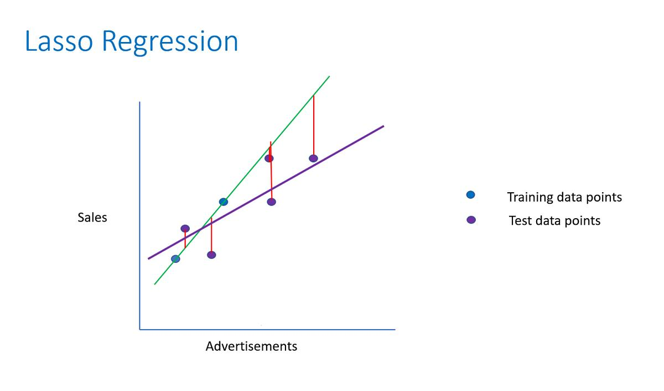
5
- Also prevents overfitting
- Can remove useless features (make them zero)

Gradient Descent:-
1.)Weight Vs cost func
2.)global min

Linear Regression:-
Linear Regression – Quick Notes
Definition
A method in Machine Learning to predict continuous values
Finds a straight-line relationship between input and output. y=mx+b. y → predicted value
x → input
m → slope (impact of x on y)
b → intercept (starting point). Goal
Find the best-fit line
Minimize error between actual (y) and predicted (ŷ)
Error / Loss Function
J(θ)=n∑(y−y^)2
Measures how wrong the predictions are
We try to minimize this
How it works (simple)
Start with random line
Calculate error
Adjust slope & intercept
Repeat (using Gradient Descent)
Get best line
Linear relationship
No extreme outliers
Errors are random
🔹 Types
Simple Linear Regression → 1 input
Multiple Linear Regression → multiple inputs
🔹 Example
Input: House size
Output: Price
👉 Bigger size → higher price
🔹 Pros
Simple & easy to understand
Fast to train
🔹 Cons
Only works well for linear relationships
Sensitive to outliers
1.)Accuracy:-
Accuracy= (TP+TN)/FP+FN TP+TN ​
Simple meaning:Out of all predictions, how many were correct?
Intuition: Good when data is balanced Can be misleading if classes are imbalanced Example: If 95% data is negative, predicting everything as negative → high accuracy but useless
2. Precision
Precision=TP/(TP+FP)
​ Simple meaning: Out of all predicted positives, how many are actually correct?
Intuition: Focuses on quality of positive predictions
High precision = low false positives Example: Spam detection → If you mark email as spam, it should really be spam
3. Recall (Sensitivity)
Recall= TP+FN TP ​
Simple meaning: Out of all actual positives, how many did we correctly detect?
Intuition: Focuses on capturing all positives High recall = low false negatives
Example: Disease detection → Better to catch all sick patients (even if some false alarms)

ROC (Receiver Operating Characteristic)
What it is:
A curve/graph
Plots:
X-axis: False Positive Rate (FPR)
Y-axis: True Positive Rate (Recall)
Simple meaning:
Shows how model performance changes at different thresholds
AUC (Area Under the Curve)
What it is:
A single number (area under ROC curve)
Simple meaning:
Measures overall model performance
Key Difference (1-liner)
ROC → Graph showing performance
AUC → Number summarizing that graph
Interpretation
AUC = 1 → Perfect model ✅
AUC = 0.5 → Random guessing ❌
Higher AUC = better model

